# Ryan Demboski

# Ordering result sets

The following exercises use the “supermarket” database

1. Return id, name, type and price of all items, ordered by price, ascending.

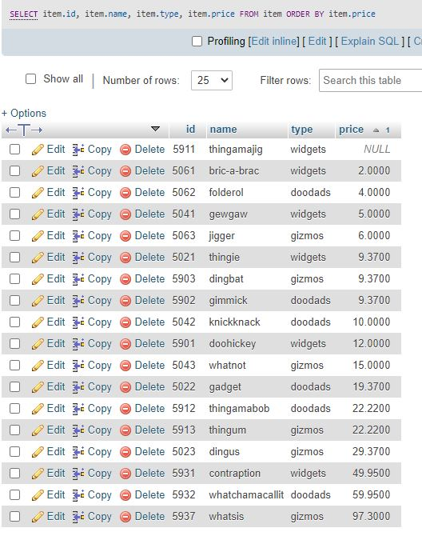

1. See #1 above, but ordered descending.

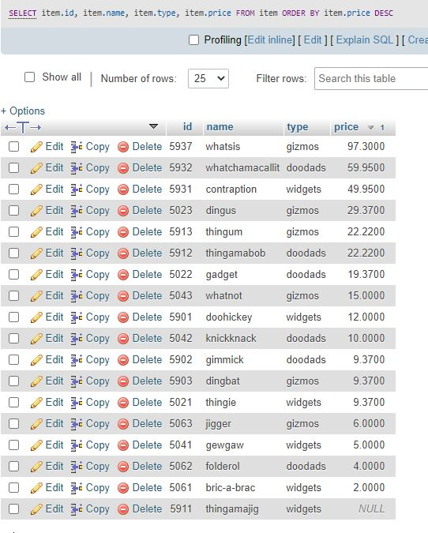

1. Use the shopping view of the prior exercise to return customer name, cart id, item name, quantity, item price and the total of the price per returned record (that means, e.g., that when A. Jones bought three gimmicks, the total is $28.11), ordered by total.

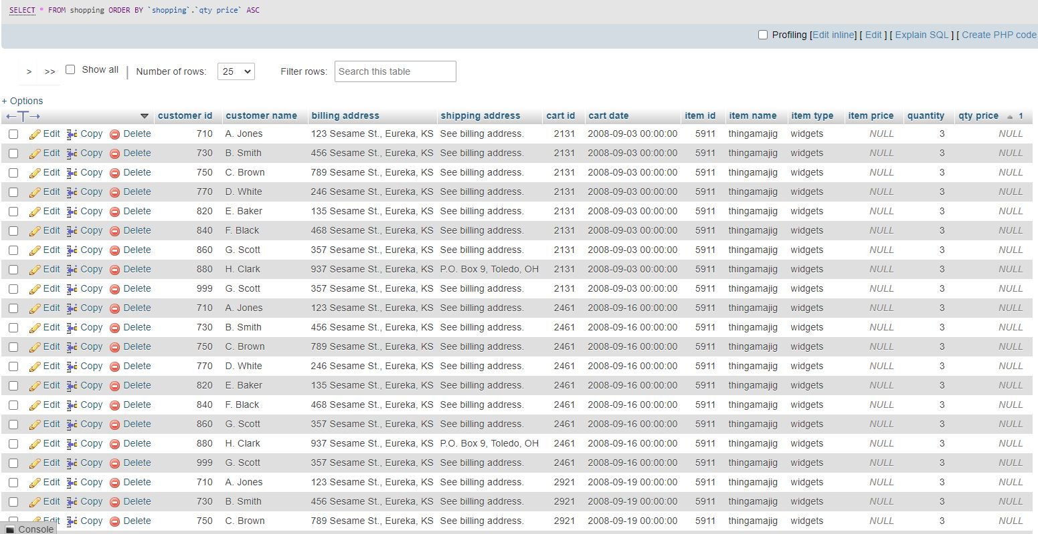

1. Return customer name, card id, item name, quantity, item price and total (per record, see above), ordered by customer name, cart id and item name.  
   